**Topic -** Weather Prediction

Using the Columns :

* precipitation

* temp_max

* temp_min

* wind

We are going to predict the weather condition :

* drizzle

* rain

* sun

* snow

* fog

**Dataset -** [WEATHER PREDICTION | Kaggle](https://www.kaggle.com/datasets/ananthr1/weather-prediction?resource=download)

**Visualizations -** Power BI

**Algorithms -** Colab Notebook

**Visualizations on Power BI**

1. Bar Graphs of all attributes -

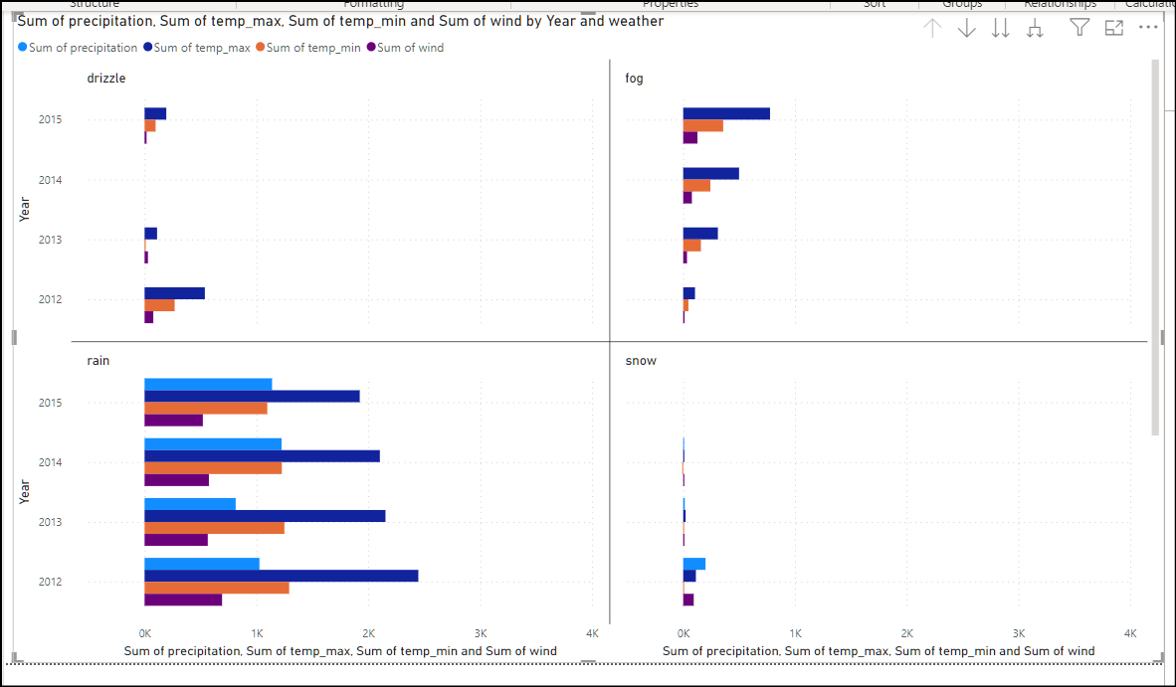

2. Line chart of max temperature v/s weather v/s date

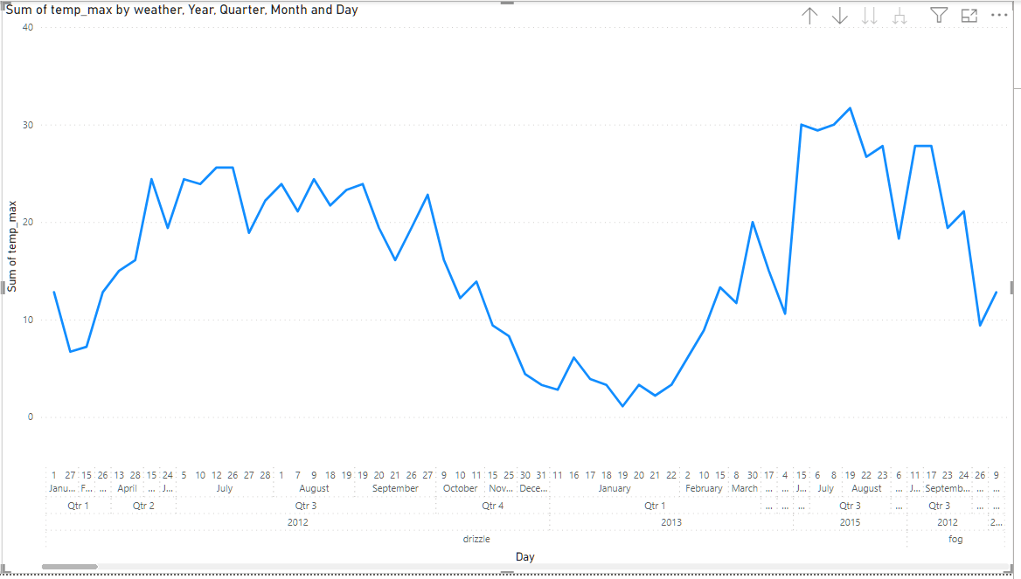

3. Pie Chart of weather v/s precipitation

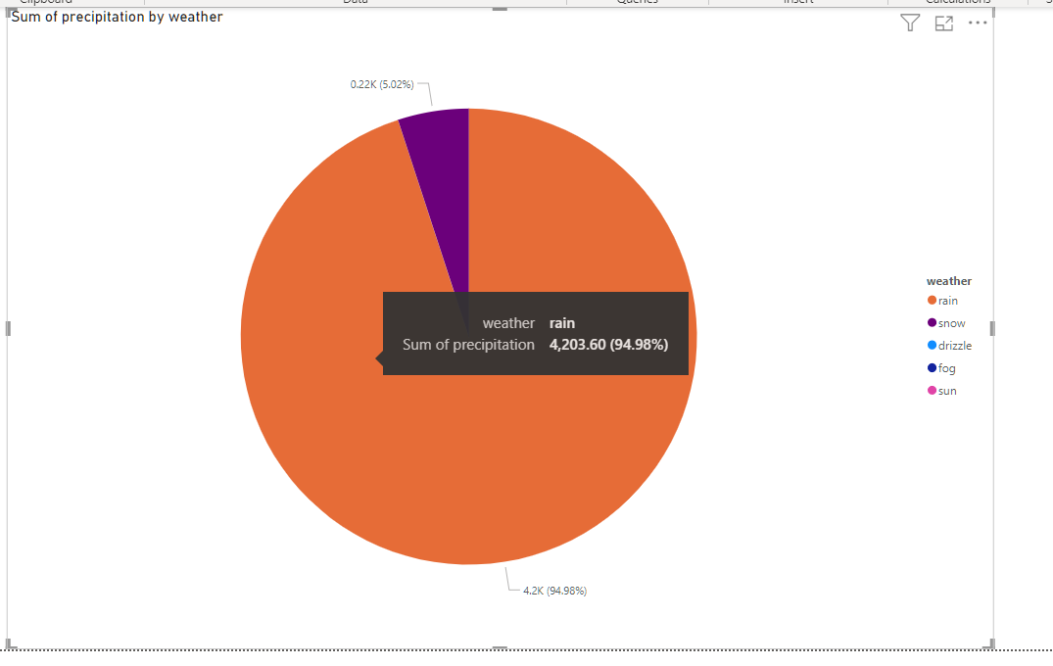

4. Pie chart of min temperature v/s max temperature v/s weather

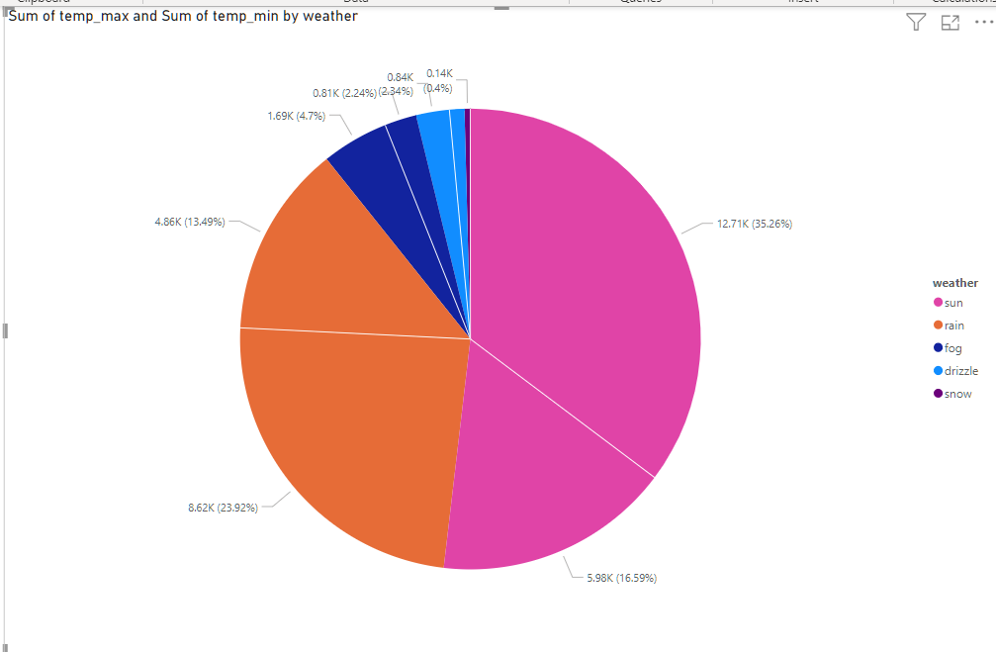

5. Tree map of all attributes

